**Document describing in detail how you’ll handle the launch of your first product and how you’ll meet solvency requirements. This should be a Google Doc based on the LEHO Business Case template doc, which you will link in the wiki.**

| FREE FEATURES | PAID FEATURES |
| --- | --- |
| Personality and body(chemical) scan | Extra+1 or 2 traits |
| 3 additional traits on top of base profile | More than 3 additional traits-subscriptions |
| 2 free slots for personalities | Companies can request specific profiles or data scans |
| Switching back to base personality | Companies can supply specific profiles |
| Base personality | Buy more profile personalities |
| Consult information about the scan | Sell scans of people to companies that have left the product |
| Coming back is free | To get the premium features back you have to pay the price of your used slots again to have the possibility to change to it. |
| Referral to mental health | More profile slots increase in price |
| Cooldown between traits | Consultations on personality modifications |
|  |  |
|  |  |
|  |  |
|  |  |
|  |  |

Massive list of traits:

Strength of traits?

https://liveboldandbloom.com/02/self-awareness/list-of-personality-traits

**Joe Johnson:**

Base Profile 0- Free profile and free scan. - dashboard

-Aspiring

-Asocial

-Understanding

-Greedy

**Profile 1 - buy for 50**

-Clever(free trait/included in price of profile)

**Profile 2 - buy for 100**

-Clever(as well)

-Polished

**Profile 3- buy for 200**

-...any trait

-...any trait

-...any trait

**Profile Ultimate-??**

-...any trait

-...any trait

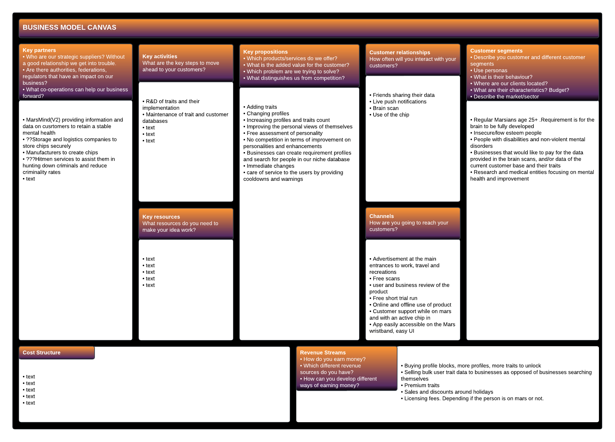

Questions to 3rd year student:

1. What was the most important thing?

**Business case.** As in documentation, the risk assessments, revenue just a lot of documentation, around 30 pages is the norm. Refer to 6.1 in project briefing.

For financial calculations: used excel sheets. do 5-10 year revenue streams. Graphs and statistics. Show the dividend returns to the investors. Proof of concept for the software on the wristband, as in wireframes.

Lots of colorful pictures.

Actually write our risk assessments in detail and their solutions.

Colorful graphs with information.

Where we get our investments from. And give exact numbers how much money is needed for the app. Keep in mind the percentage of shares of the company, how much would be available to the public.

1. Code wise, how much is needed?

Not that much. they made an API, and they’re mostly GET, so with java they made a returnable list for food recipes. Choose a comfortable database to work. Need documentation about the API, “this GET gets this” and etc.

1. What’s a good documentation?

Good documentation is where you can see easily what is going on from the paperwork alone. Make it work and make it correct.

1. What could have been better?

Didn’t focus on investor and them giving money or them owning the company.

1. End presentation.

Basically like sharktank. When you make POC, make sure to not talk in technical terms, but more laymen accessible.

1. Minus points for:

Not participating. More points for cooperation. Make the application interesting to use and buy. The questions asked may be odd, but the most part is to convince to buy the product.

1. For wireframe: just make the outline from the features, don’t do too much.

-Risk assessment idea: stealing chip from a person and installing another one into your own head.

Fake it till you make it:

Example from 3rd year: fake a wifi connection with the chip, instead just connect using ssh

**BUSINESS PART IS WAY MORE IMPORTANT**

Exponentially increase price

5-15 year look ahead for finances

Excel => graphs

(can put it in business case)

To convince investors: in x years you can get your money back

We want this much, you will get this much in return.

Can someone buy more than 50% of your company? If yes => they basically own your company

Where do we get our materials from? How do we store our products?

openAPI as documentation for server-side

IDEA: monitor temps of chip, if dangerous levels give a warning and a possible solution!

‘Watch’ screen: check your chip temp/profile

Big screen setting: company dashboard /

Big screen setting: user wanting to change profile or trait